Design Guideline

Date: December 27, 2021

RE: Public Address & Electronic Signage System

Public Address & Video Message System

This document provides design guidance to developers or contractors (herein referred to as the project team) working on the public address and electronic signage system (often referred to as “PA/ESS,” “PA/VMS,” or, colloquially, the “countdown clocks”). This document exists to *complement* the technical specifications that are on the MBTA's website, and linked to below.

Summary
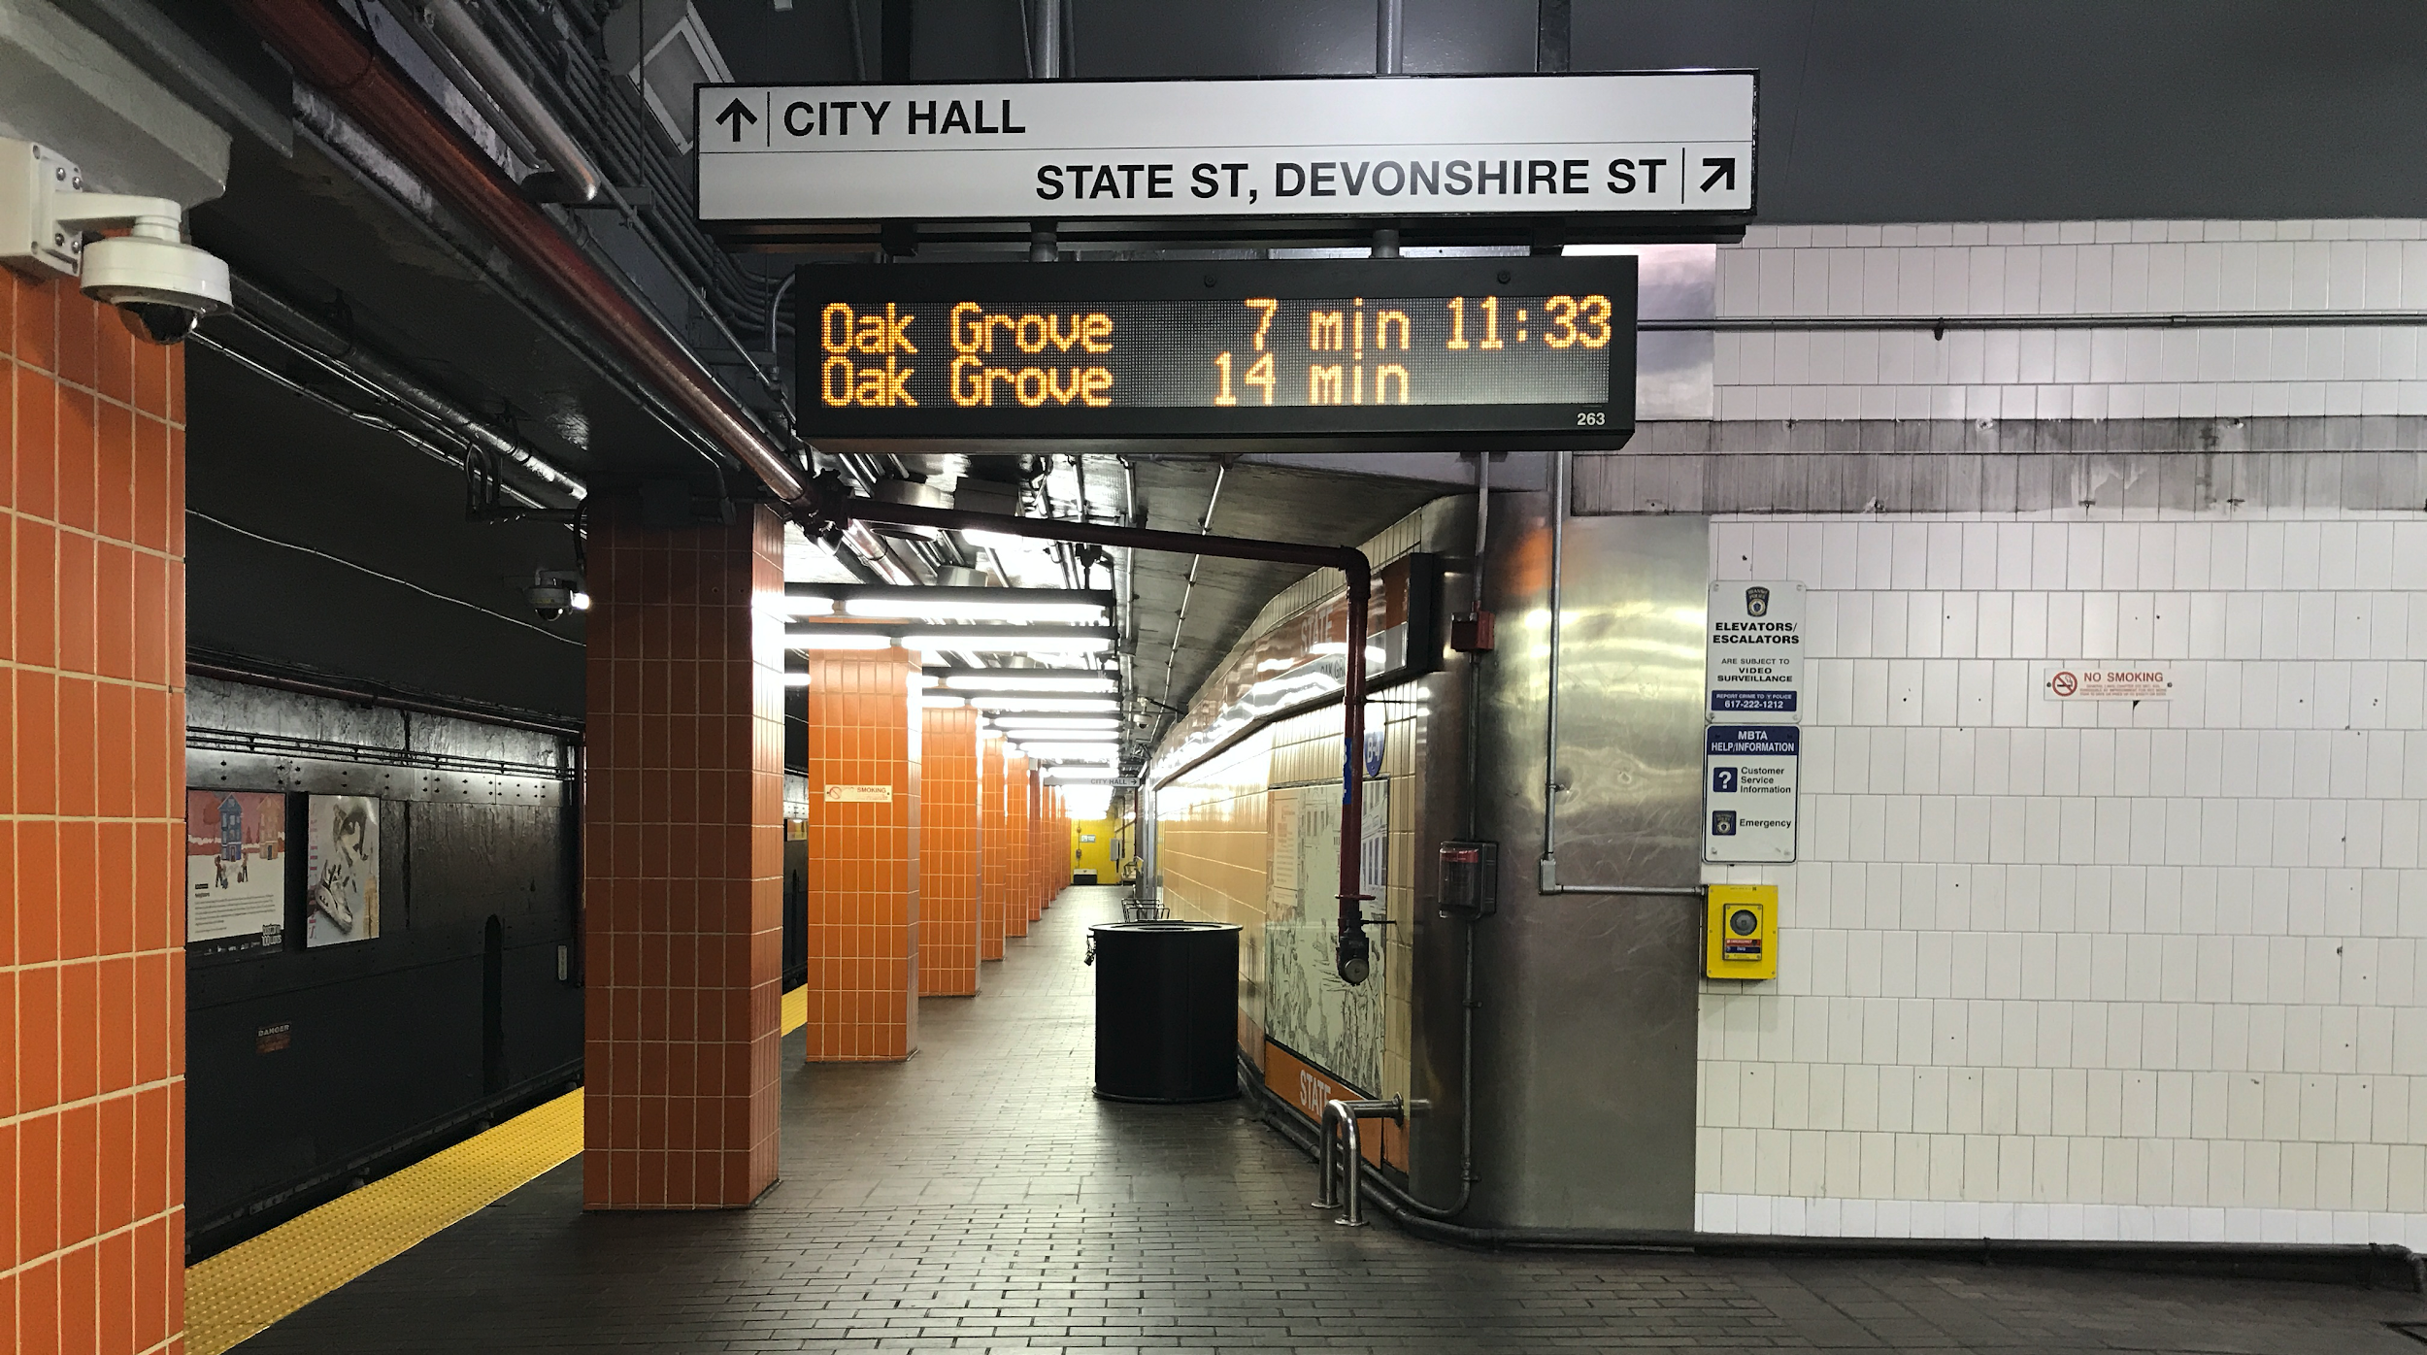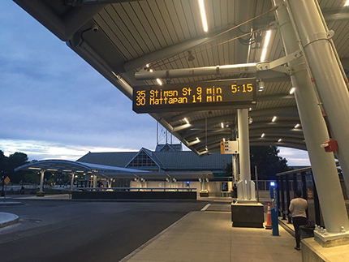

The MBTA’s PA/ESS system includes:
- Public announcements – both programmable (audio announcements match the visual displays of real-time arrival information and public safety announcements) and live (ability to make emergency announcements system-wide)
- Visual displays - provides riders with real-time arrival information and public safety announcements (often referred to as countdown clocks or variable message signs)
These countdown clocks are located at the majority of our rapid-transit/subway stations, as well as some bus stations.

Technical Specifications
For the latest PA/ESS technical specifications, please check the MBTA website.

Design Guidance
At a minimum, countdown clocks placement must meet Americans with Disabilities Act (ADA) requirements. The key elements include, but are not limited to:
- acoustical considerations
- visibility for riders
- not obstructing sight lines to wayfinding signage or emergency egress signage
- mounting heights

The project team shall work with CTD on countdown clocks placement recommendations. Final design shall include a coordinated effort with MBTA System-Wide Accessibility (SWA) and MBTA Wayfinding.

General
- At least one countdown clock shall be visible and legible when standing on any portion of the platform
- Three double-sided countdown clocks per platform at a minimum. Center running platforms shall have at least three double-sided countdown clocks per direction for a minimum of six
- Light rail platforms are generally shorter in length and deviation from three minimum may be considered in consultation with SWA and Wayfinding
- Countdown clocks shall also be placed in the mezzanine / lobby and at a visible location from the fare gate

Note that sightline issues (or other considerations) may necessitate installation of additional countdown clocks beyond the minimum requirements.

When choosing a location, whether on the platform, in a lobby or mezzanine, or at a busway, please consider the following:
- feasibility of running conduit/feeds
- available structure to suspend these signs
- whether signs may block sightlines to architectural elements such as: stairs and elevators; suspended elements such as overhead wayfinding signs, emergency exit signs, lighting fixtures, security cameras, sprinkler heads; architectural details that preserve functional or aesthetic design of the building, etc.
- physical distance from other signage: countdown clocks must be a minimum of 2 feet from other types of signage and advertising.

Location on Platform
Countdown clocks on the platform will be placed perpendicular to the tracks, in alignment with wayfinding signage but spaced such that all signs remain visible. When choosing platform locations for countdown clocks, please consider the following:
- proximity to points of entry onto the platform
- locations of where people gather and wait for train arrivals
- number of different trains that may berth at a platform (which may require additional countdown clocks beyond minimum requirements)
- widths of platform being able to accommodate the width of the countdown clocks to ensure they are installed perpendicular to the train tracks. In extremely rare conditions, limited width may necessitate an alternate solution such as parallel signage or placement across the tracks. Deviation from perpendicular placement must be reviewed and approved by the Office of the Chief Engineer and System-Wide Accessibility.
- Whether the sign obstructs train movement – do not overhang above tracks or where a train door opens (e.g. older Greenline trollies)

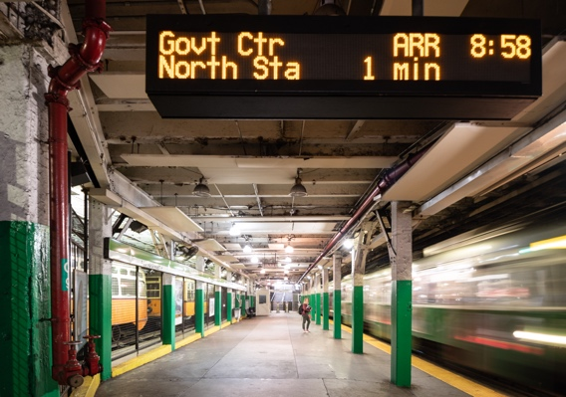

Location in Lobby / Mezzanine
Countdown clocks are often positioned above the fare gates, or in the center of the lobby / mezzanine. It is important to provide information to riders *before* they pay their fare – so these locations shall be selected to ensure riders see them as they are entering the station and as they are making their way to the fare gate. When choosing lobby / mezzanine locations for countdown clocks, please consider the following:
- key paths of travel from the neighborhood, bus stops, bike and vehicle parking lots, transfers from other rapid-transit lines, etc.

Special considerations shall be made for stations that are a significant distance from initial station entry (e.g. multiple levels underground, a long walkway, a crossover). Countdown clocks shall be placed at initial points of entry for these stations.

Location at Busways
Countdown clocks shall be included at busways that have a wired power source, such as busways that are part of a rapid-transit/subway station. Countdown clocks are important for riders who are waiting for their bus, as well as bus riders arriving at a station to transfer to the rapid-transit line. Please consider the following:
- locations of where people gather and wait for bus arrivals
- path of travel as riders exit a bus and head to rapid-transit
- Whether the sign obstructs bus movement – do not overhang where a bus may hit sign while pulling in
- accommodations for a new audio and visual zone for the busway countdown clocks

Large LCD screens may also be a good option for the busway. Please coordinate with CTD.

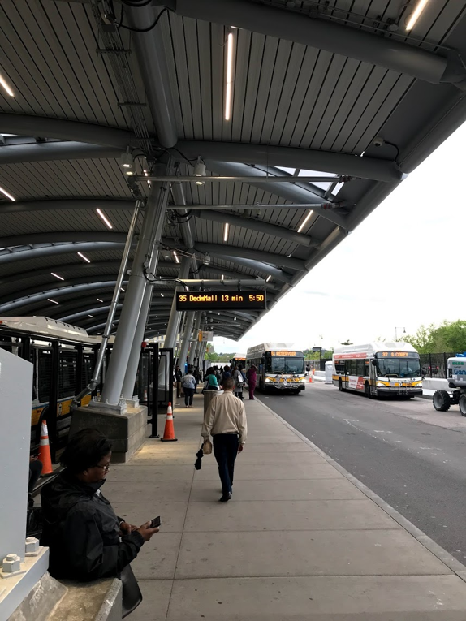

Acoustical Considerations
The number and location of audio speakers will vary by station or platform due to the unique acoustical considerations of each location. Project teams shall include acoustical engineering in their scopes, and consider things like track/wheel squeal, ambient noise, and noise spillover into nearby neighborhoods in determining where to install speakers. High ambient noise levels, in particular, can make stations hostile or extremely difficult to navigate for white cane users, people with hearing impairments, and certain cognitive disabilities.

In-Station Microphones
Microphones that allow for local, in-station public announcements shall be installed: one microphone shall be placed in each of the Communications Room cabinets that house PA equipment and one (or two if station has a separate inbound and outbound platform) in a location that an in-station agent has easy access to a microphone – such as a customer service agent box.

Contact Information

Customer Technology Department (CTD)
General email
customertech@mbta.com

System-Wide Accessibility
General email
swa@MBTA.com

Wayfinding
Katherine Knowlton, Manager of Graphics & Wayfinding
kknowlton@mbta.com
Alice Molari, Graphics & Wayfinding Coordinator
amolari@mbta.com

Commuter Rail
This document does not cover signs at commuter rail stations. Questions regarding commuter rail signs should be directed to customerservice@keoliscs.com

As required by the Daniels-Finegold settlement agreement

